Why History?
History is the study of past events and societies. As well as giving you useful general knowledge about the past, History helps you to understand the world we live in now and form opinions about issues you read about in newspapers or see on television.
Course outline
The course is made up of three main units: You will learn how to use a variety of information resources such as libraries, documents, photographs, early maps and computer databases. By studying evidence from the chosen period, you will develop understanding of the problems of the time and be able to discuss and debate the issues.

HISTORY Advanced HIGHER
Details of Course Components

The course has one compulsory units including an added value unit called a Dissertation that assesses your knowledge & skills.

- Historical Study: 90 marks
In this unit you will:
• develop techniques to comment on historical sources and answer essay based questions on historical issues related to the field of study
• learn more about themes and events within an area European History
Field Of Study:
• Germany: From Democracy to Dictatorship, 1918-1939
- Historical Assignment: Dissertation: 50 marks
Added Value Unit: History Assignment : Dissertation In this unit you will:
• choose an issue to research related to the field of study
• write up the study which is worth 50 marks overall
• use a variety of research methods

ASSESSMENT
Your work will be assessed by your teacher on an ongoing basis throughout the course. Items of work might include:
• written work, research assignments, presentations & tutorials
• Progress tasks related to the Dissertation
• class-based timed assessment (sources and essays)
• You will also sit a written exam marked by the Scottish Qualification Authority (SQA) which is worth 90 marks (2 x 25mark essays and 3 source based answers worth a total of 40 marks—12, 12, 16 marks demonstrating each source based skill of judging: usefulness, completeness and assessing viewpoints)

The exam will consist of a mixture of knowledge and skill based questions. Part One will focus on essay questions. Part Two will be based on Historical skills and will focus on the source based skills. The exam paper is 3 hours long but it is suggested that candidates spend 1 hour 30 minutes on each part.

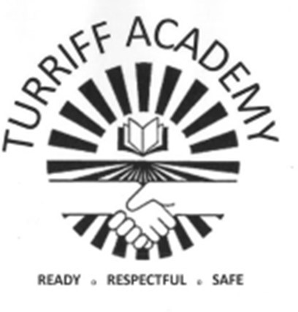

FACULTY OF HUMANITIES
Geography Staff:
Mr Michael Forsyth
Miss Laura Smith
Mrs Shakira Alecio-Allen PT Equity/Skills

History Staff:
Mr George Baird PT Faculty
Mrs Fran Mottashaw

Modern Studies Staff:
Mrs Alison Gray
Mr Matthew Low

RMPS Staff:
Mrs Hannah Barraclough

Courses in Humanities Faculty:
National 3 Geography
National 4 Geography
National 5 Geography
Higher Geography
Advanced Higher Geography

National 3 History
National 4 History
National 5 History
Higher History
Advanced Higher History

National 3 Modern Studies
National 4 Modern Studies
National 5 Modern Studies
Higher Modern Studies

Higher Politics

National 4 RMPS
National 5 RMPS
Higher RMPS

Useful websites to help you with your choices:
www.myworldofwork.co.uk www.skillsdevelopmentscotland. co.uk
Further advice and information on these options is available from your subject teacher, guidance teacher and careers adviser.

