Why History?
History is the study of past events and societies. As well as giving you useful general knowledge about the past, History helps you to understand the world we live in now and form opinions about issues you read about in newspapers or see on television.
Course outline
The course is made up of three main units: You will learn how to use a variety of information resources such as libraries, documents, photographs, early maps and computer databases. By studying evidence from the chosen period, you will develop understanding of the problems of the time and be able to discuss and debate the issues.

HISTORY HIGHER

Details of Course Components

- Historical Study: Scottish
In this unit you will:
• develop techniques to comment on historical sources
• learn more about themes and events within an area of Scottish history from the Medieval, Early Modern or Later Modern period
Including:
• Migration and Empire 1830-1939

- Historical Study: British
In this unit you will:
• develop techniques to comment on the impact of historical developments
• learn more about events and themes of British history from the Medieval, Early Modern or Later Modern period
Including
• The Atlantic Slave Trade, 1770-1807

- Historical Study: European and World
In this unit you will:
• develop your skills to comment on factors that contribute to historical developments
• earn more about events and themes of European and world history
Including:
• Germany 1918-1939

Added Value Unit: History Assignment
In this unit you will:
• choose an issue to research using a range of skills
• write up the assignment using a structured template under exam conditions within 1 hour 30 minutes
• a variety of research methods will be chosen and used by the pupils to learn more about their chosen issue such as surveys, interviews, observations, reading, the media and the internet.

ASSESSMENT
Your work will be assessed by your teacher on an ongoing basis throughout the course. Items of work might include:
• written work - research assignments, reports and case studies
• projects
• class-based assessment
• You will also sit a written exam marked by the Scottish Qualification Authority (SQA).

The exam will consist of a mixture of knowledge and skill based questions. Paper one will focus on essay questions from — British, European and world history. Paper two will be based on Historical skills and will focus on Scottish history. Each paper will last 1 hour 30 minutes.

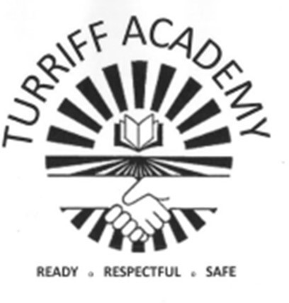

FACULTY OF HUMANITIES
Geography Staff:
Mr Michael Forsyth
Miss Laura Smith
Mrs Shakira Alecio-Allen PT Equity/Skills

History Staff:
Mr George Baird PT Faculty
Mrs Fran Mottashaw

Modern Studies Staff:
Mrs Alison Gray
Mr Matthew Low

RMPS Staff:
Mrs Hannah Barraclough

Courses in Humanities Faculty:
National 3 Geography
National 4 Geography
National 5 Geography
Higher Geography
Advanced Higher Geography

National 3 History
National 4 History
National 5 History
Higher History
Advanced Higher History

National 3 Modern Studies
National 4 Modern Studies
National 5 Modern Studies
Higher Modern Studies

Higher Politics

National 4 RMPS
National 5 RMPS
Higher RMPS

Useful websites to help you with your choices:
www.myworldofwork.co.uk www.skillsdevelopmentscotland. co.uk
Further advice and information on these options is available from your subject 2teacher, guidance teacher and careers adviser.

